-

<https://newrelic.com/>

-

-

-

-

# What is New Relic? How does it work? New Relic features, importance, competitors,

[**BIRAJ**](https://www.devopsschool.com/blog/author/biraj/)**FEBRUARY 21, 2022**[**LEAVE A COMMENT**](https://www.devopsschool.com/blog/what-is-new-relic-how-does-it-work-new-relic-features-importance-competitors/#respond)

**New Relic: An Overview**

New Relic is a San Francisco, California-based technology company which develops cloud-based software to help website and application owners track the performances of their services. New Relic is an observability platform that helps you build better software. You can bring in data from any digital source so that you can fully understand your system and how to improve it.

New Relic is an Application Performance Management (APM) used by teams for application monitoring. The idea is to maximize productivity and minimize downtime by monitoring application statistics that reflect overall application performance.



Managing modern web applications requires attention to small details because often these little things come together that adversely affect the user experience. The New Relic Application Monitoring Tool reveals these parameters so that developers and site owners can take appropriate and timely corrective actions necessary to improve the performance of **WordPress** sites.

Another distinguishing feature the application monitoring tool offers is the **ability to track performance in real time**. **This is important if the site receives unexpected traffic and the site is likely to go down**.

Today New Relic has become a vital tool in any developer toolkit that is preferred due to its high reliability and exceptional features.

**What you can do with New Relic:**

Bring all your data together: Instrument everything and import data from all your technology stacks using our agents, integrations and APIs, and access it from one UI.

Analyze your data: Get all your data at your fingertips to find the root causes of problems and optimize your system. Build dashboards and charts or use our powerful query language.

Respond quickly to incidents: Our machine learning solution continuously detects and explains discrepancies and warns you before they become a problem.

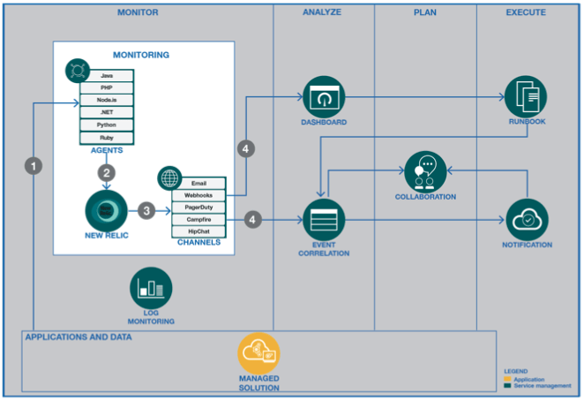

**How New Relic works:**The new Relic APM collects and stores metrics and data from web-based and other associated applications within the enterprise. New Relic receives data over the network and then processes and analyzes it. Users view the data through a dashboard-type interface.

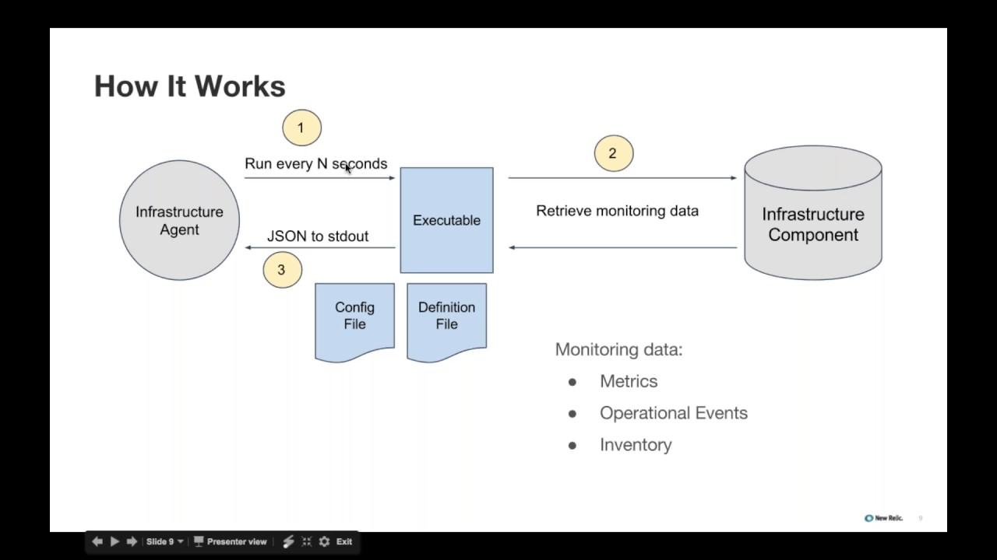

**New Relic APM features:**New Relic APM software as a service has a feature set intended to collect data, analyze the data and report relevant performance metrics to IT administrators and other application stakeholders.

New Relic uses agents – small chunks of code installed in the application or application environment. Many agents handle a wide range of applications, and users can find agents in C (as an SDK), Go, Java, .NET, Node.js, PHP, Python, and Ruby.

* https://www.techjockey.com/assets/images/chek-m.jpg Network Monitor
* https://www.techjockey.com/assets/images/chek-m.jpg Network Management
* https://www.techjockey.com/assets/images/chek-m.jpg Application Monitoring
* https://www.techjockey.com/assets/images/chek-m.jpg Database Monitoring
* https://www.techjockey.com/assets/images/chek-m.jpg Availability & Error Monitoring
* https://www.techjockey.com/assets/images/chek-m.jpg Reports
* https://www.techjockey.com/assets/images/chek-m.jpg Team collaboration

**An example using a web application illustrates how New Relic works**: An agent collects a series of performance details, such as how long the code needs to build each webpage and page load times. Administrators can review these details, identify any factors that may be delaying performance, and determine the root of the delay. The dashboard indicates issues in real time and tracks trends over time. When a problem is detected, administrators and developers can take corrective action — such as a code update — and then compare performance differences to objectively determine the impact of any changes.

As a SaaS offering, New Relic retains metrics and other data – not the user. Organizations seeking long-term analysis or sensitive compliance requirements may need to consider the data retention policies of a SaaS provider prior to adoption.

**New Relic competitors:**New Relic competitors include AppDynamics, Datadog, Dynatrace, SignalFx and Splunk Technology. An APM tool can be part of the IT toolset for years, so evaluate each prospective tool carefully — compare features, benefits and costs – prior to a final decision.

-

-

-

-